**English Project of Halloween**

**History:**

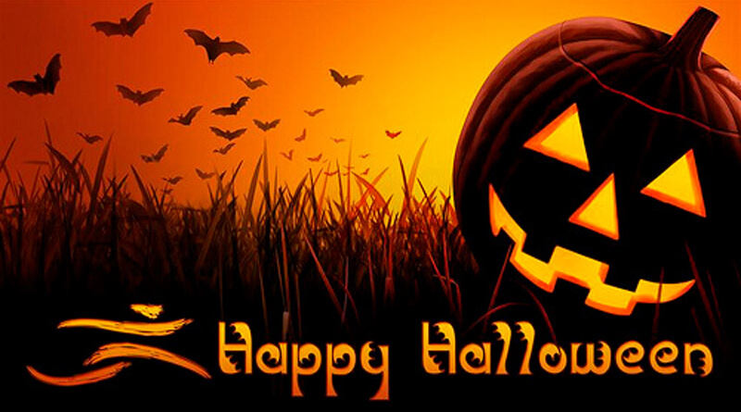Hallowen is a tradition that Will be celebrate at 31 of October. In the party, children dress up as a character that sacres and goes to the houses of the neighbor asking trick or treat. The history of Halloween and its tarditions date back more tan 2.000 years.

Trick: its refer the children that make a prank lark when they don’t want give sweeties.

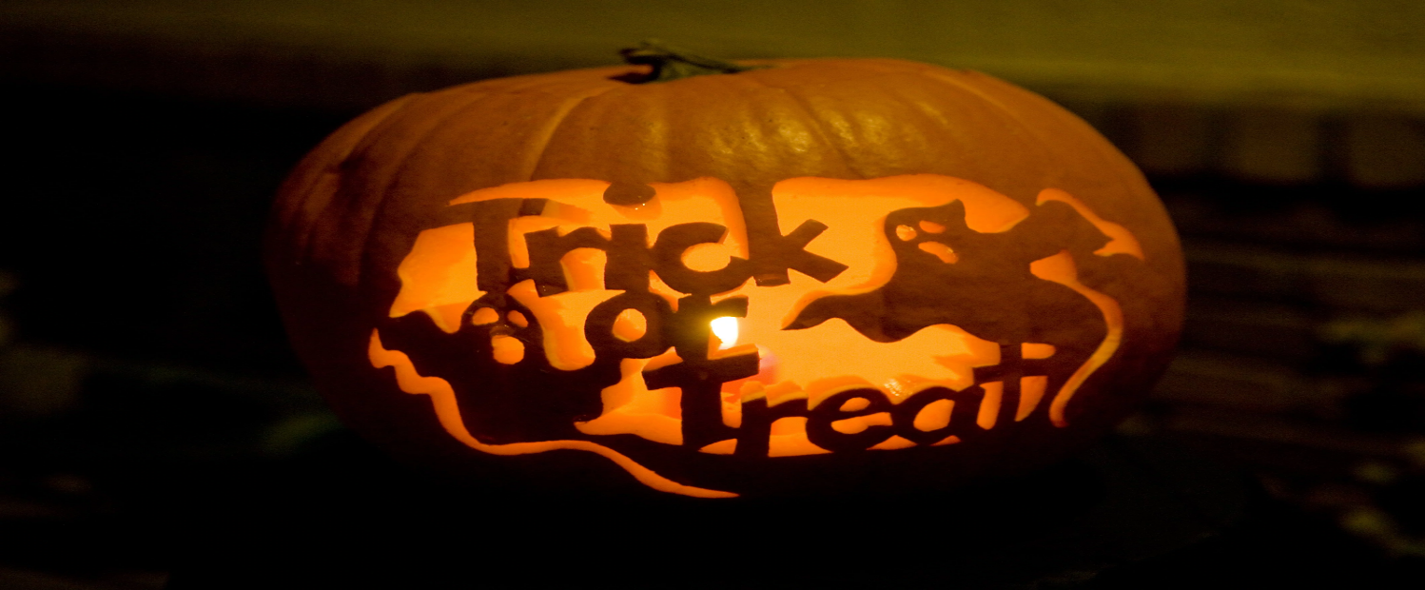Treat: its when give sweeties at children and they do not anything to you.

**Characteristic of halloween?**

Legend has it that witches, who many belived worshipped the devil, would protect their identities by turning themselves into black cats.